Python Program

Q.1) Convert given hrs & mins in second

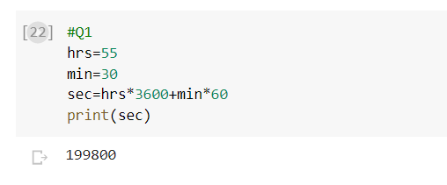

Q.2) Write code to find the average of ‘n’ numbers entered by the user to function avg ( ). Ex: avg (10, 20, 30, 40) => average is: 70 avg (5, 10, 15) => average is: 10

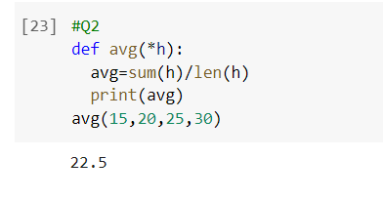

Q.4) Write a code to accept a number & print in words. Ex: 123 Three Two One

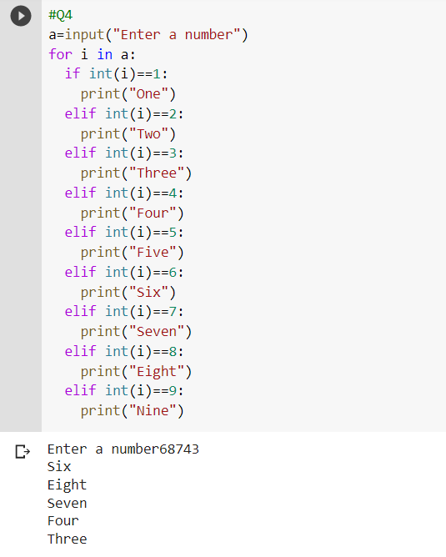

Q.5) Create class

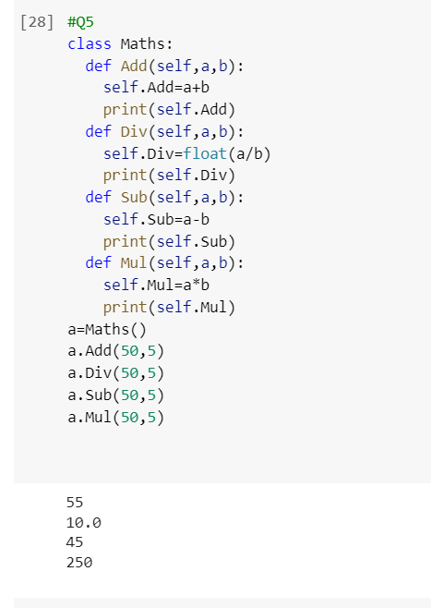

Q.8) Print

1

3 3

5 5 5

6 6 6 6 7 7 7 7 7

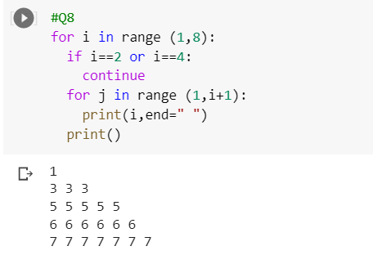

Q.9) Accept String & print only alternate characters on a string. Ex: this i s a _ test

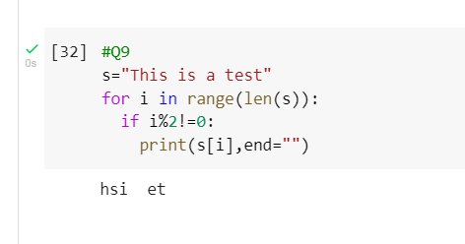

R Program:

1. Write a R program to create a sequence of numbers from 20 to 50 and find the mean of numbers from 20 to 60 and sum of numbers from 51 to 91.

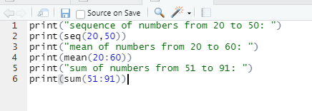

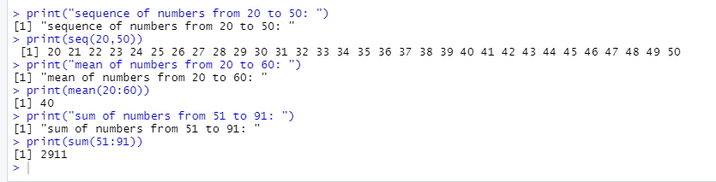

1. Write a R program to print the numbers from 1 to 100 and print "Fizz" for multiples of 3, print "Buzz" for multiples of 5, and print "FizzBuzz" for multiples of both

